A000-Afr-Ghana-Tchamba people, Wooden mask, 19th c

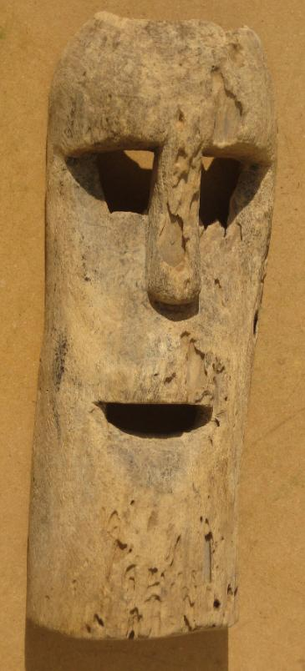

Fig. 1. Ghana-Tchamba people, Wooden mask, 19th c

Case no.: 6

Accession Number:

Formal Label: Ghana-Tchamba people, Wooden mask, 19th c

**Display Description:**

This rare Tschamba ceremonial mask was found in the vicinity of Tamale, Ghana. The Tchamba were originally an indigenous tribe of northern Ghana, located in the areas of Tamale, Bim Billa, Konkonba (Tikokonba), and Nanumba. Due to major tribal wars, they had to flee to the location of present day Tchamba, now in Tchamba Prefecture in the Centrale Region of Togo. Two drill holes (one field repaired) on either side for raffia decoration or hold-strap.

**LC Classification:**

Date or Time Horizon: 19th c

Geographical Area: northern Ghana

**Map:**

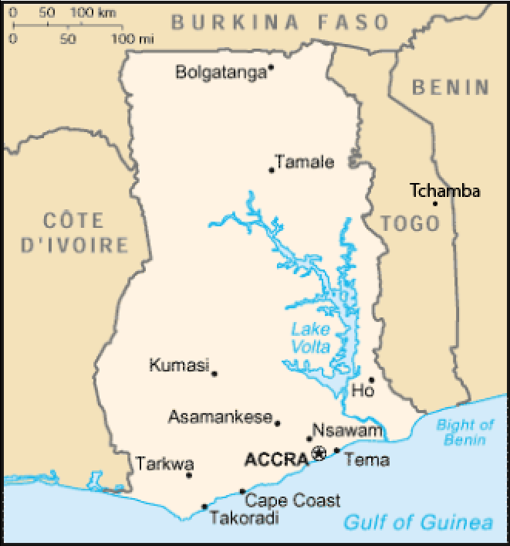

**Fig. 2. Map of Tamale in Ghana and Tchamba in Togo after**

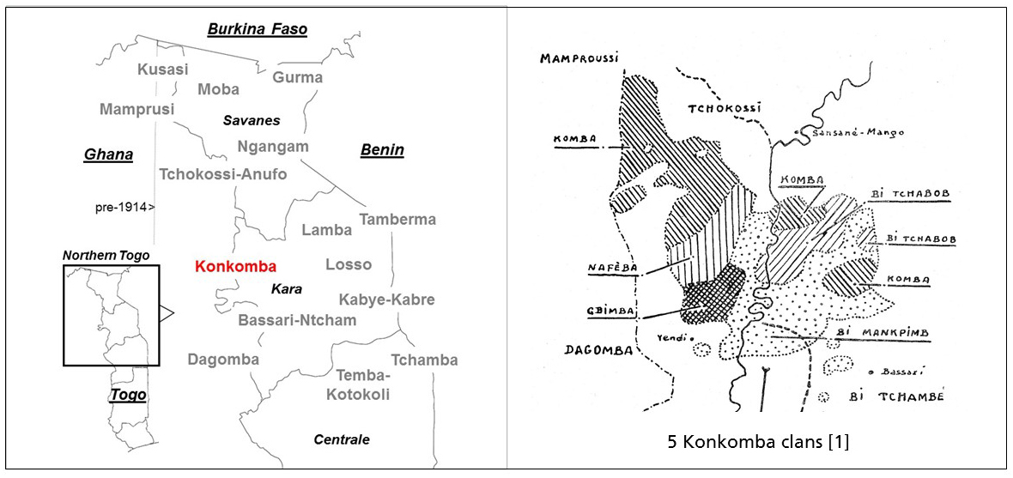

Fig. 3. Map of Tchamba relocation areas in Togo after https://1.bp.blogspot.com/-snO5vIV_qN8/WRFOfswh94I/AAAAAAAAAK4/i0O8LaSf9YUvKZzItPikkbzE5yE2Vy1oACLcB/s1600/Konkomba.jpg

**GPS coordinates: Tamale, Ghana:**

Cultural Affiliation:

Medium: Light-to-medium density wood, with superficial insect damage

Dimensions: 14 inches tall by 5.4 inches wide.

Weight: 1.1 lbs.

Condition: original

Provenance: Tamale, Ghana

**Discussion:**

This mask was possibly carved before the late 19th c migrations, since it was found in Tamale. The first stop of the Tchamba in Togo was Bassar. Then they moved to the place called Tchamba, in the north of Togo. Their language is also Tchamba. Originally their religion was animist as this mask in the shape of a tree spirit makes evident, but once removed to Togo they were converted to Islam and that is when they became slave traders of non-Muslims. The area into which they were thrust was a patchwork of different groups so the Tchamba decided to keep to themselves, away from the main road in Togo.

**References:**